**RE-Production Deployment from Docker**

Step1:- After build and testing from qa server then download the solar-ui and webapp file from staging docker container as below snapshot.

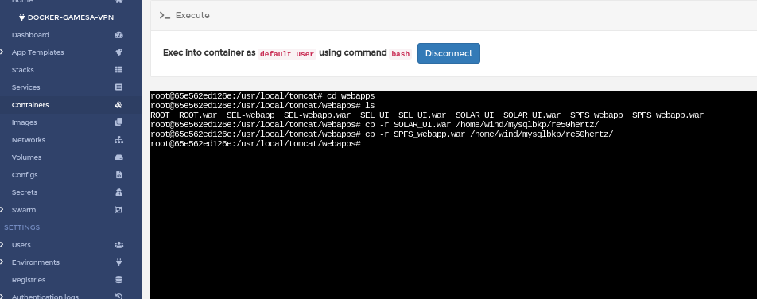

Step2:- download the both file from /home/wind/mysqlbkp/re50hertz location

# cd /home/rajeev/awsprod/solar_ui

#scp -r [root@205.147.98.133](mailto:root@205.147.98.133):/home/wind/mysqlbkp/re50hertz/*.war .

#ls

Dockerfile ROOT.war SEL_UI.war SEL-webapp.war SOLAR_UI.war SPFS_webapp.war

Step3:- docker file should be exit on this location.

#vim Dockerfile

FROM tomcat:8-jre8

MAINTAINER "Devops <linux.support@manikarananalytics.in>"

ENV CATALINA_OPTS="-Dserver.mode=prod -Duser.timezone=Asia/Kolkata"

ADD ROOT.war /usr/local/tomcat/webapps/

ADD SEL_UI.war /usr/local/tomcat/webapps/

ADD SEL-webapp.war /usr/local/tomcat/webapps/

ADD SOLAR_UI.war /usr/local/tomcat/webapps/

ADD SPFS_webapp.war /usr/local/tomcat/webapps/

RUN rm -rf /usr/local/tomcat/webapps/ROOT

EXPOSE 8080

CMD ["catalina.sh", "run"]

save this file

Step4:- change the servermode and database properties

# vim SPFS_webapp.war

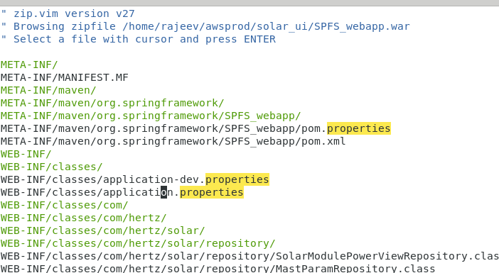

Step5:- Change the servermode from application propertes

spring.profiles.active=qa

to

spring.profiles.active=prod

save this file

Step6:- update the application-prod-properties

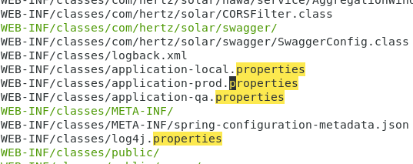

spfs.datasource.driverClass=com.mysql.cj.jdbc.Driver

to

spfs.datasource.driverClass=com.mysql.jdbc.Driver

spfsScada.datasource.driverClass=com.mysql.cj.jdbc.Driver

to

spfsScada.datasource.driverClass=com.mysql.jdbc.Driver

hawa.datasource.driverClass=com.mysql.cj.jdbc.Driver

to

hawa.datasource.driverClass=com.mysql.jdbc.Driver

hawaScada.datasource.driverClass=com.mysql.cj.jdbc.Driver

to

hawaScada.datasource.driverClass=com.mysql.jdbc.Driver

save this page

Step7: Build the docker image for deployment on production.

#docker build -t 50hertz/energy:solar-50-master-date .

#docker tag 50hertz/energy:solar-50-master-date 50hertz/energy:solar-50-master-date

#docker push 50hertz/energy:solar-50-master-date

Step8: pull the image on production for deployment

# click the service of RE-UI and fill the current image on url then apply as below

